Please follow the below procedure to create a new project from a template

1. Download and save the designer template from TIBCO team site on your machine. Below is the link for downloading the template

<https://github.com/mirabul/TIBCOTemplate/raw/master/TIBCOEKTemplate.designertemplate>

1. Open **TIBCO Designer**, you will be presented with the below screen. Click on ‘**New project from Template**’ option

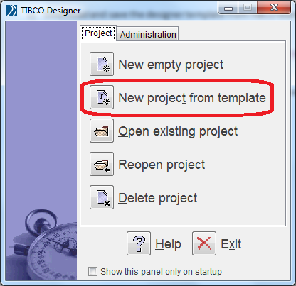

1. Browse the **designertemplate** file downloaded in Step 1 and click on **’Open’**

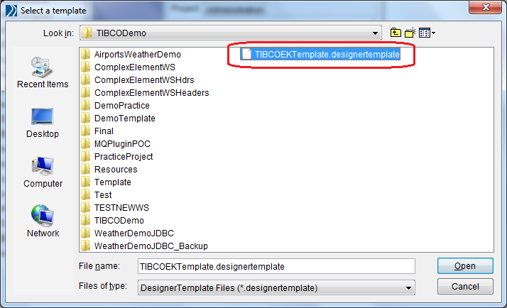

1. An untitled project will be created with the standard project folder hierarchy

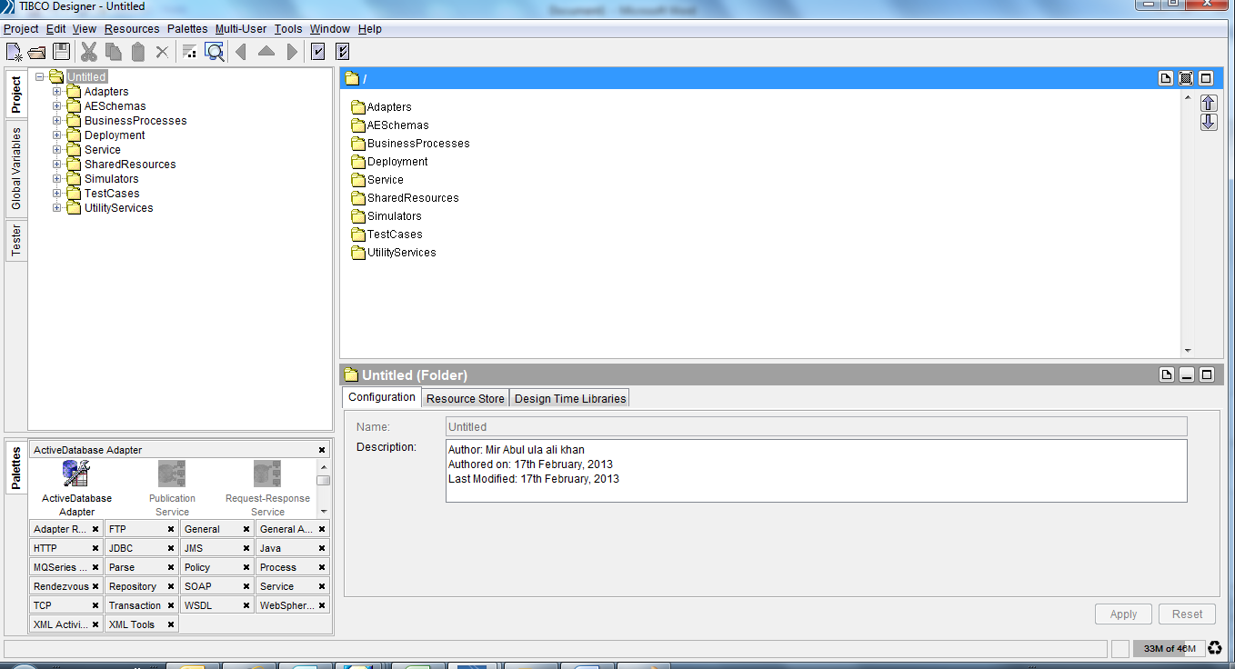

1. Save the project with appropriate name and start adding your processes

**Note**: Please do not change the folder names. You can add new folders and global variables depending on your project requirements